# **REQUESTOR INFORMATION**

|  |  |  |  |  |  |
| --- | --- | --- | --- | --- | --- |
| **(To be accomplished by new registration/replacement of existing user)** | | | | | |
| **Name of Bank/Institution** | | | | | **Date of Request** |
|  |
| **Complete Address** | **Bldg./ Floor/ Unit No.** |  | | **Street** |  |
| **Village/ Subd.** |  | | **Barangay** |  |
| **City/ Municipality** | | | **Province** |  |
| **Zip Code** |  | | | | |
| **Name of Authorized User** |  | |  | |  |
| (Last Name) | | (First Name) | | (Middle Name) |
| **Position Title of Authorized User** |  | | **Department/ Office/ Unit/ Group** | |  |
| **E-mail address** |  | | **Contact Number** | |  |

# **DETAILS OF REQUEST**

|  |  |  |
| --- | --- | --- |
| **Type of Request:** | | |
|  | **NEW USER** | |
|  | New registration | 1. **Registration for:**  |  |  | | --- | --- | | BSP Relationship Management System (BRMS) Portal | | |  | |  |  | | --- | --- | | Agent Registry | IOD Portal | | CRIMS | ORLS | | IFSS Submission Portal | Others:  ITRS Weekly Report and/or  ITRS Monthly Report | | | Machine-to-Machine (for Digital Certificate)  *Please accomplish Annex A - Certificate Signing Request (CSR)* | |  1. **Existing user to be replaced**: (applicable for the replacement of existing user)  |  |  |  | | --- | --- | --- | | Name of Existing User | : |  | | Email address | : |  | |
|  | Replacement of existing user[1] |
|  | **EXISTING USER:** | |  |  |  | | --- | --- | --- | | Name of Existing User | : |  | | Email address | : |  | |
|  | Update User Information/Access | 1. **Specify information to be updated**:  |  |  | | --- | --- | | **From** | **To** | |  |  | |  |  | |
| 1. **User Access:**   Add: *ITRS Weekly Report and /or ITRS Monthly Report*  Revoke: *[specify application system/module]*  *(See Item II.A for the list of modules for reference)* |
|  | Delete/Remove Existing User | 1. **Delete Access and User**  |  |  |  | | --- | --- | --- | | Effective Date | : |  |   *Note: Request must be submitted at least 30 days before the effective date.* |

|  |  |  |  |
| --- | --- | --- | --- |
| **Agreement**  I hereby certify that all the information provided are true and correct and I acknowledge that I am binding myself to comply with the Terms and Condition/Participation Agreement of the BSP Relationship Management System. | | **Certified by:**  This is to further certify that only electronic submissions originating from the authorized user of the [Name of Bank/Institution] shall be accepted and recognized by the BSP – Department of Economic Statistics as the official submission. | |
| _______________________  Signature over Printed Name of Authorized User | __________  Date | _______________________  [2]Signature over Printed Name of Designated signatory per Corporate Secretary | __________  Date |

# **APPROVAL OF REQUEST**

|  |  |  |  |
| --- | --- | --- | --- |
| ***(To be accomplished by BSP-concerned Department/Office)*** | | | |
| **With existing access to other modules? (** YES / NO)  **Module/s to be accessed:** | | | |
| Approved | Denied | **Remarks:** |
| REDENTOR PAOLO M. ALEGRE, JR./ SENIOR DIRECTOR/ DES | |
| Signature over Printed Name of the Authorized Approver  Date: | |

**ACTION/S TAKEN:** (applicable only for **approved request**)

|  |  |
| --- | --- |
| **Registration to BRMS Portal:** (TDIO Administrator) | |
|  | Remarks: |
| Signature over Printed Name of TDIO Administrator  Date: |
| **Verification and Assigning of Role in Selected Module/s:** (BSP Department/ Office Administrator)  Note: Applicable for New Registration/Replacement of Existing User | |
|  | Remarks: |
| Signature over Printed Name of Authorized BSP Department/Office Administrator  Date: |

**Accomplish and Submit User Registration Form (URF):**

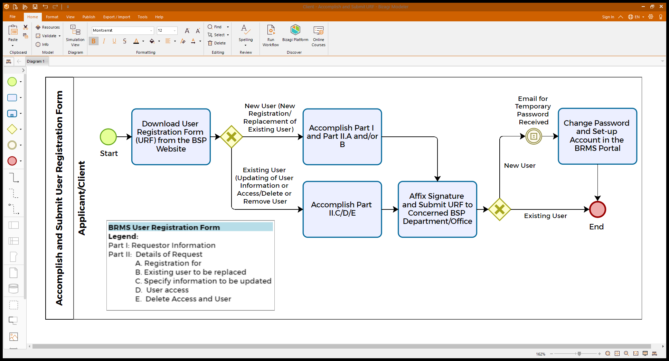

**Reminders:**

1. Submit the accomplished and signed form/s to: (as applicable depending on the selected module/s to be accessed)

|  |  |  |
| --- | --- | --- |
| **Modules** | **BSP Department/Office** | **Email Address** |
| Agent Registry | Financial Inclusion Office (FIO) | [agentregistry@bsp.gov.ph](mailto:agentregistry@bsp.gov.ph) |
| IFSS Submission Portal  ORLS | Department of Supervisory Analytics (DSA) | [brms_urf@bsp.gov.ph](mailto:brms_urf@bsp.gov.ph) |
| CRIMS | Credit Reporting System Unit (CRSU) | [crsu@bsp.gov.ph](mailto:crsu@bsp.gov.ph) |
| ITRS | Department of Economic Statistics | [ESSG-ITRS@bsp.gov.ph](mailto:ESSG-ITRS@bsp.gov.ph) |

*Note: For any inquiries/clarification, you may send an email to the concerned BSP Department/Office.*

1. User Registration Form with incomplete/inaccurate information will be returned to the requestor.
2. The new user must immediately change password and set up account in the BRMS Portal (https://brms.bsp.gov.ph/) upon receipt of the temporary password.

Note: Password may contain combination of the following:

* Alphanumeric characters;
* Both upper and lower case characters (e.g. a-z, A-Z); and,
* Special characters (e.g. !@#$%^&*()+|~-=\`{}[]:”;’<>?,./)

1. Password must not be shared with anybody. Registered user/s must be responsible in protecting the secrecy of password.

**TERMS AND CONDITIONS**

1. The BSP Relationship Management System (BRMS) is a common integrated system available to provide digital services to BSP Stakeholders.
2. The BRMS can be used for registration, licensing, reportorial, advisory, and other related services. It is a Portal which enables participant1 to do the following:
   1. submit report for processing;
   2. get report status; and
   3. get report status file.
3. The requested user access is provided for the exclusive use of the participant. New participants are required to accomplish and submit the User Registration Form (URF) to request for a digital certificate/ log-in credential to authorize report submission and facilitate access/connectivity with the system.
4. The BSP shall handle the Administrator function of the system.
5. The participant shall be responsible for any hardware/software upgrades required to support remote access to the system.
6. It is the participant’s responsibility to ensure that only those registered users are authorized to access the system. Propagating the system configuration is considered a security breach and is a ground for the termination of the access to the system. The BSP can revoke, block, or permanently disallow the use of the system without prior notice due to reasons that may compromise internal security. The BRMS system and all information inside is the sole property of the BSP. Any unauthorized distribution, dissemination or use of any information, media, and the like, outside of its intended purpose is not allowed.
7. Subject to the participant’s registration:
   1. The system will send a credential login request to the registered email. That email will contain a one-time link that will prompt end-user to enroll his/her password; and
   2. The concerned BSP Department/Office will provide instructions on how to access the system, URL, and username that participant will use.
8. The BSP shall not be held responsible for any loss, liability or damage caused by errors and mistakes of the participant or by processing failures as a consequence of machine/computer malfunctions due to fortuitous events/force majeure or analogous causes and shall be held free and harmless from claims, suits, costs and damages attributable thereto. Furthermore, the BSP shall not be made party to any dispute nor be held answerable for any liability in connection with, arising out of, or in relation to any transactions covered by this URF. The BSP shall be held free and harmless from claims, suits, costs, and damages attributable to the participant.
9. Each participant shall be responsible in promptly checking the correctness of the submissions and generated results of the system as well as notifying BSP of any system errors so discovered.
10. Each participant shall be responsible for providing and/or establishing its own back-up/ contingency plans to ensure that electronic instructions shall be successfully transmitted to the system in the event of failure of its primary hardware and/or computer.
11. In case of any security breach or problem, the participant should report immediately to the concerned BSP Department/Office indicated in the URF, to trigger the investigation of the said security breach or problem and prompt corrective action can be performed. BSP has the right to disable a user account without prior notice in case of any suspected or reported incidents.
12. Each participant expressly agrees to be legally bound by the electronic instruction it sends through the system provided they comply with the terms and conditions set forth in the URF. The BSP records will be the evidence of the participant's dealings with the BSP in connection with the system. The participant agrees to the admission of the BSP records as evidence in any legal proceeding although such records are electronic, not in writing or produced by a computer.
13. This agreement shall be governed by the laws of the Republic of the Philippines.

1. Two-factor authentication of the existing user will be deleted/removed.
2. Authorized official for this registration form should belong to authorized signatory for category A-3 reports per Manual of Regulations on Foreign Exchange Transactions.